**LAB REPORT: LARSON SCANNER (ENHANCED)**

Brandon Ackerman – RBT173

**Introduction**

For this laboratory, I was tasked with the creation of the Larson Scanner, named after Glen A. Larson. For those that do not follow television (like me), Larson was the producer of Battlestar Galactica. The Larson scanner works by programming a string of light-emitting diodes (LED’s) to “scan” from one end to the other, then back again indefinitely. Unfortunately, my physical components did not arrive in time to build the scanner, so this project was completed in Tinker cad. They did however arrive on Saturday, so I will be able to use the kit going forward.

The circuit for my scanner uses 6 LED’s, 6 Resistors, and the Arduino UNO platform. I calculated the resistor value using the formula $resistor=\frac{Battery Voltage-LED Voltage}{desired LED current}$. Since the LED’s are connected in parallel to the 5V pins, a resistor value of 150 Ω is used to provide each LED with 2V 20mA.

As a follow-up assignment, it was requested that we modify the code to work with any number of LED’s. This was achieved by creating two additional variables. These variables are linked to the first and last LED’s in the scanner, replacing the pin numbers specified in the loop. By changing these lines, we are now able to add and remove LED’s to the scanner using the stLED variable, and the endLED variable.

**Implementation**

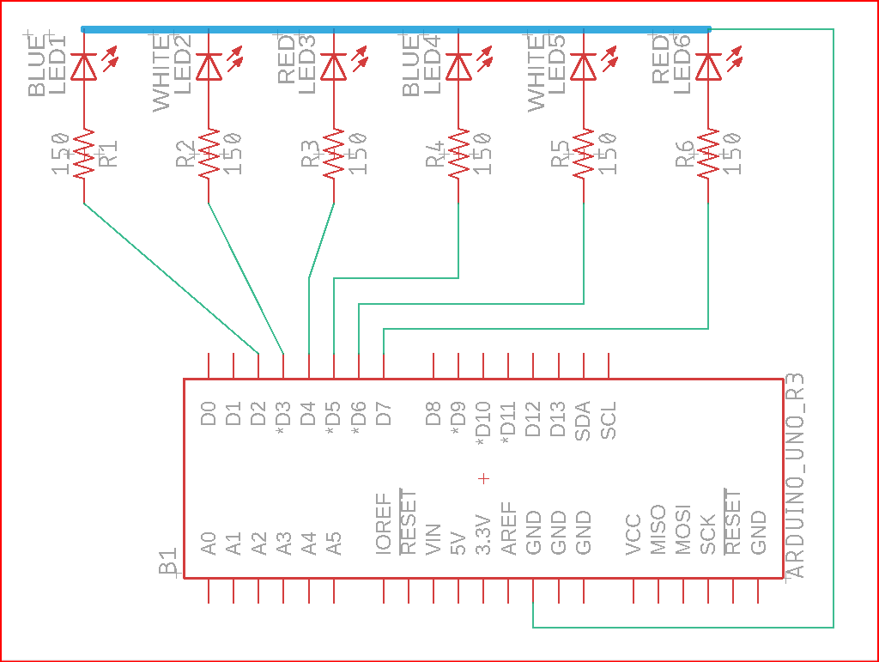

EAGLE DIAGRAM

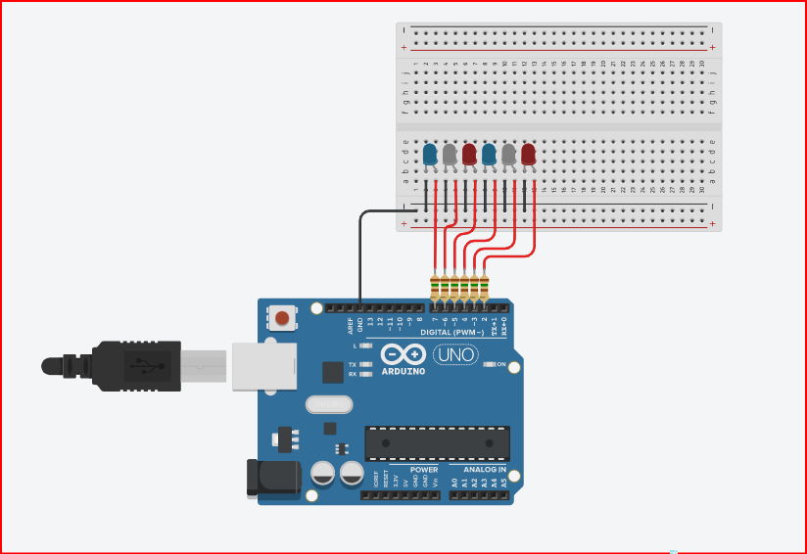

CIRCUIT

[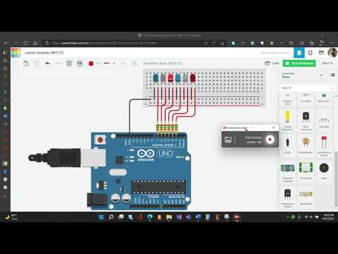](https://www.youtube.com/embed/oFiS255Ka4o?feature=oembed)

VIDEO

*////Larson Scanner 3, RBT173*

*////Brandon Ackerman*

*////////////////////////////////////////////*

*//GLOBAL VARIABLES:*

*//global variable for delay time adjustment.*

*int delayTime = 250; //I wanted it to go faster, so I assigned it a value of 200ms.*

*int endLED = 7; //variable that defines which pin is the last in the series.*

*int stLED = 0;//variable that defines which pin is the first in*

*//////////////////////////////////////////////*

*//SETUP CODE:*

*void setup()*

*{*

*//for loop to create a starting pin and an ending pin.*

*for (int i = stLED; i <= endLED; i++)*

*{*

*pinMode(i, OUTPUT); //assigns int "i" as a output.*

*}*

*}*

*/////////////////////////////////////////////*

*//MAIN CODE LOOP:*

*void loop()*

*{*

*for (int i = stLED; i <= endLED; i++) //if "i" is equal to pin 2 and is less than or equal to pin 7, add an output incrementally up to pin 7.*

*{*

*digitalWrite (i, HIGH); //turn on pins as defined in line above.*

*if (i == stLED) //if int i is equal to the starting LED, set the last LED in the sequence to low.*

*{*

*digitalWrite (endLED, LOW); //turn off the last LED in the sequence.*

*}*

*else*

*{*

*digitalWrite (i - 1, LOW); //incrementally turn off pins.*

*}*

*delay(delayTime); //delay time set by global variable.*

*}*

*for (int i = (endLED-1); i >= (stLED+1); i--) //if "i" is equal to pin 6 and is greater than or equal to pin 3, remove outputs incrementally up to pin 7.*

*{*

*digitalWrite (i, HIGH);*

*if (i== stLED+1)*

*{*

*digitalWrite ((i + 1), LOW); //incrementally turn off pins.*

*delay(delayTime); //delay time set by global variable.*

*digitalWrite (stLED + 1, LOW);*

*}*

*else*

*{*

*digitalWrite ((i + 1), LOW);*

*delay(delayTime); //delay time set by global variable.*

*}}}*